**Task No. 1:** How can I install Ubuntu on VirtualBox and what steps are involved? Can you provide instructions or images to guide me through the process?

**Solution:**

1. 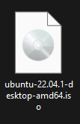Download and install VirtualBox: First, download VirtualBox from the official website and install it on your computer.
2. Download Ubuntu ISO image: Next, download the Ubuntu ISO image from the official Ubuntu website.
3. Create a new virtual machine: Open VirtualBox and click on "New" to create a new virtual machine. Follow the prompts to choose a name, type, and version of the operating system.

1. Allocate resources: Assign resources such as RAM, storage space, and number of CPUs to the virtual machine according to your requirements.
2. 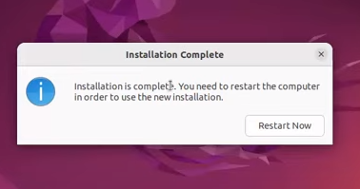Install Ubuntu: Select the newly created virtual machine and click on "Start". When prompted, select the Ubuntu ISO image you downloaded earlier as the installation media. Follow the on-screen prompts to install Ubuntu on the virtual machine.

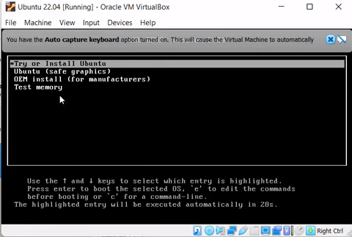

1. Configure Ubuntu: Once the installation is complete, Ubuntu will boot up in the virtual machine. Follow the prompts to configure the system settings such as language, keyboard layout, and user account information.

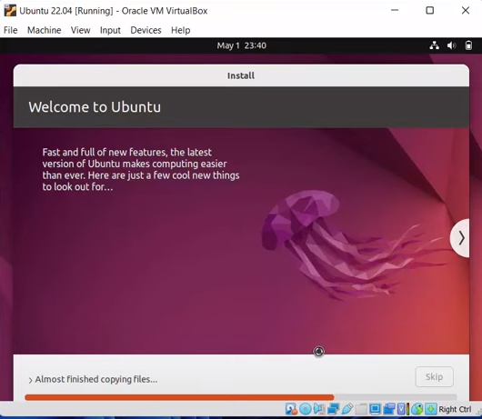

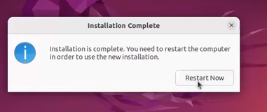

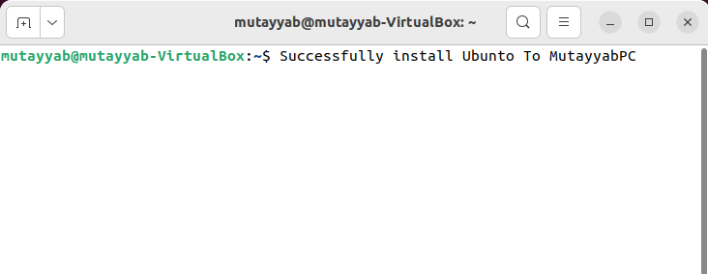

1. Install VirtualBox Guest Additions: Finally, install VirtualBox Guest Additions on the Ubuntu virtual machine to enable features such as shared folders, seamless mouse integration, and better video performance. To do this, select "Devices" from the VirtualBox menu and choose "Insert Guest Additions CD image". Follow the on-screen prompts to complete the installation.

**Task No. 2:** By using the command line shell interface, practice the commands given in this lab. Write briefly about the usage of each command.

**Solution:**

|  |  |
| --- | --- |
| **Command** | **Function** |
| **date** | Displays the current date and time |
| **ls** | Lists the contents of the current directory |
| **ls -a** | Lists all files (including hidden files) in the current directory |
| **ls -l** | Lists files in the long format, including permissions, ownership, size, and modification date |
| **ls -h** | Lists files in a human-readable format, showing file sizes in KB, MB, etc. |
| **mkdir** | Creates a new directory |
| **mkdir -v** | Creates a new directory and displays a message indicating that the directory has been created |
| **mkdir -p** | Creates a new directory and any necessary parent directories that don't exist |
| **cal** | Displays a calendar for the current month |
| **pwd** | Displays the current working directory |
| **cd** | Changes the current working directory to the specified directory |

**Output:**

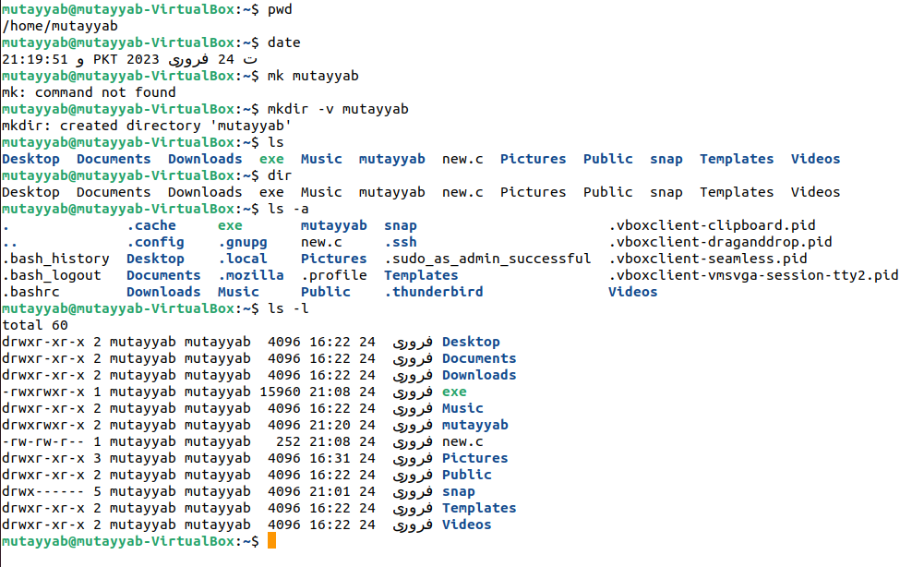

**Task No. 3:** By using gedit, open a text editor and write the C program That print your name. Save the written file as “name.c”. In order to compile and execute the output file, do the following:

$ gcc - o name name.c

$ ./name

**Solution:**

#include<stdio.h>

int main(){

printf("My Name IS Mutayyab Imran\n");

return 0;

}

**Output:**

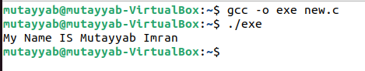

**Task No. 4:** Make changes within the above program to display a new output text as given below. Write down the developed program.

Hello World! I am studying Operating Systems.

My name is “Enter your name”.

My registration number is “Enter your registration number”.

I belong to Bahria University Karachi Campus.

**Solution:**

#include<stdio.h>

int main(){

printf("Hellow World! I am Studying Operating System\n");

printf("My Name Is Mutayyab Imran\n");

printf("My Registration Number Is 02-131212-063\n");

printf("I belong to Bahria University Karachi Campus \n");

return 0;

}

**Output:**

